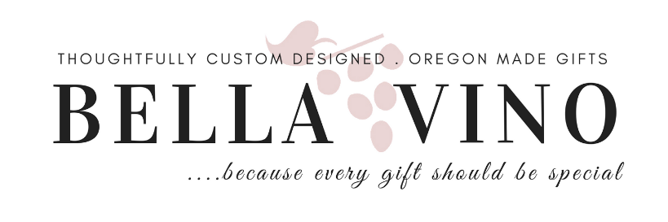

HOW TO ORDER A CUSTOM GIFT

Click on the Custom Gift Form button to tell us about your recipient. The more information we have about your recipient helps us dial-in "the special" & make it more personal.

1-DETERMINE YOUR BUDGET
- Custom Gift Minimums: Gift Basket $75, Gift Box $50 (gifts average $75-$175+)
Need Help Determining a Budget? Give us a call, we can help!

2-FILL OUT & SUBMIT ONLINE FORM
- Think about what they like, what they eat, the color of clothes they wear, the type of person they are, what would make them smile?
- Don't miss the "Request a Hand-Stamped Message" order form below for inspirational or motivational messages.

3-LOOK FOR EMAIL CONFIRMATION
- We will confirm receipt of your order within 24 hours via email. If we have any need to clarify information, we will contact you.
IF YOU DO NOT RECEIVE AN EMAIL CONFIRMATION within 24 Hours, something went awry so please call us at 541.760.0853

4-CHECK EMAIL FOR PICTURE OF GIFT
- Once we have something designed, we will email you a picture & description of contents for your approval. We will not deliver your gift until we have your approval.
- Turn around time for custom gifts is 2-3 days, depending on time of year and current order volume. October-December, allow an additional 1-2 days. If unsure, please call. We may be able to expedite your order.

5-PAYMENT
- After completion, we will email you an invoice that will have a "Pay Invoice Now" button where you will be able to pay with most major credit cards or checking debit through our merchant, PaySimple.
Questions? Call 541-760-0853 or email bellavinogiftbaskets@comcast.net

